**Kickstarter Projects Acceptance Criteria Analysis*.***

Table of Contents

**Introduction:** 1

**Data Analysis** 1

Project Category Vs Project State count: 1

Data: 1

Analysis: 1

Sub-Category vs Count of State: 2

Data: 2

Analysis: 2

Launch Date vs Count of State: 3

Data: 3

Analysis: 3

**Conclusions:** 4

**The dataset limitations:** 4

**Other possible tables/graphs that we could create:** 4

**Bonus point:** 5

# **Introduction:**

Kickstarter is a world’s largest crowd funding platform for creative projects. Kickstarter receives every year almost 300,000 projects but not everyone gets selected for Kickstarter funding. So, in this report I have analyzed past 4000 sample data projects to find out the hidden trends of Projects being accepted by Kickstarter Team.

# **Data Analysis**

# Project Category vs Project State count:

This graph helps us to understand, in past how many projects have been submitted in each categories vs how many of them are being successful, failed, canceled or lived.

Data: For this Graph I have compared the past Project categories and their state in order to find out which Category projects have higher chance of acceptance by using Bar Chart.

Analysis: The graph clearly shows the Theater, Music and Film & Video category projects have higher rate of being accepted, vs Journalism, food or publishing category.

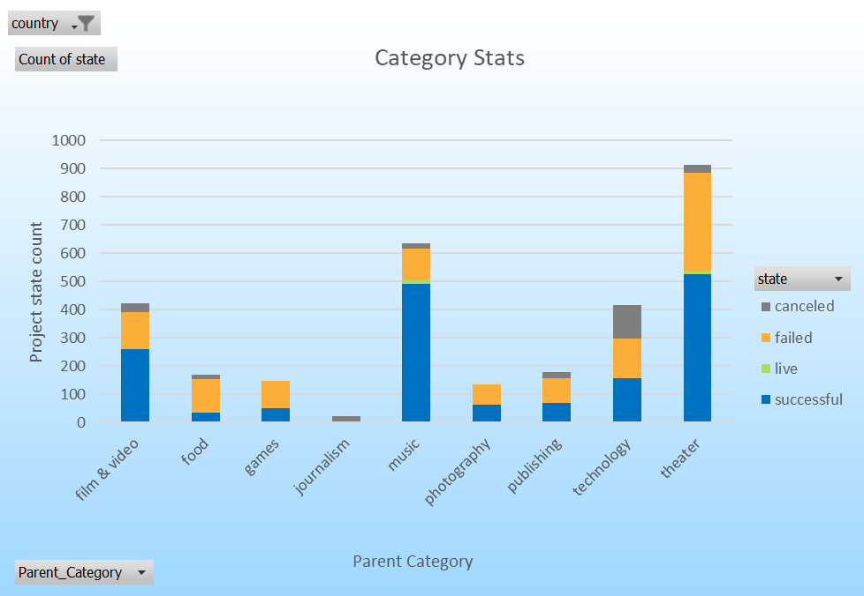

Sub-Category vs Count of State:

This graph helps us to understand in depth about Category, Sub Category projects. Among the Higher Chance of acceptance categories which subcategories would be more efficient to start projects on.

Data:For this Graph I have compared the past Project sub-categories and their state in order to find out which sub-category projects have higher chance of acceptance by using Bar Chart.

Analysis: The graph clearly shows from Theater Category, Plays sub category is more popular. From Film & Video category, Documentary, Shorts and Television projects have 100% rate of being accepted. And from Music category, Rock, Indie Rock sub-category projects have higher chance of acceptance.

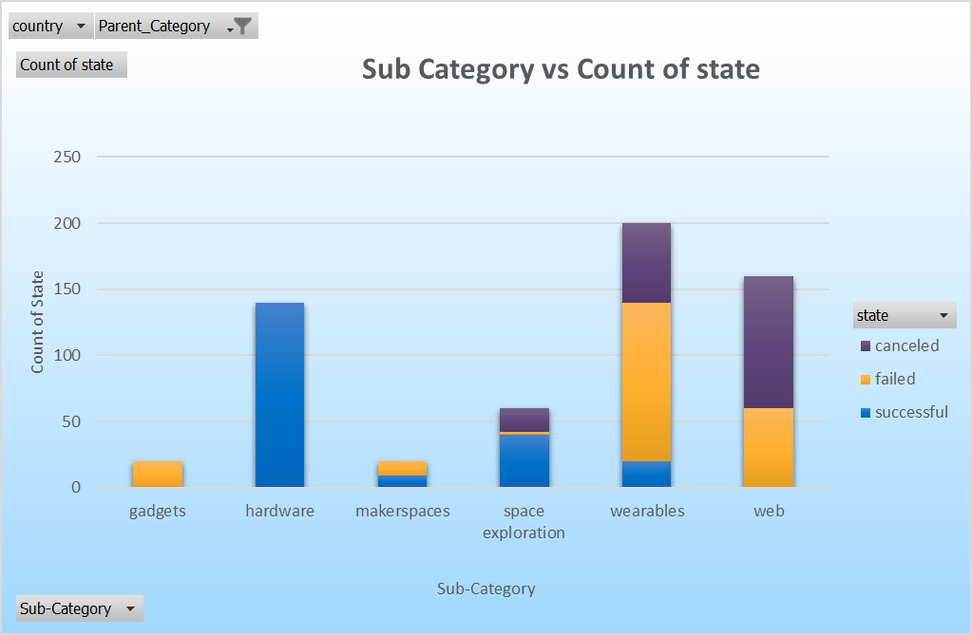

Launch Date vs Count of State:

This graph helps us visualize, project acceptance trend by the months they have submitted in.

Data: For this graph I have compared the past projects launch date and their state in order to find out the relation between project acceptance and failure by the months of the year they have submitted.

Analysis: The graph clearly shows that there is higher chance of projects being accepted if submitted in the beginning of the year vs end of the year.

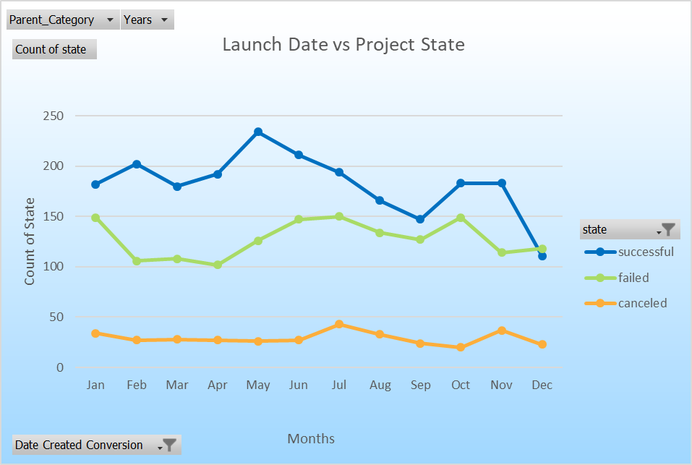

# **Conclusions:**

* Projects with fund raising goal of $1000 to $5000 have a higher chance of acceptance than the $40000 or more fund raising goal
* Projects that belong to Theater, Music, Film and Video Industry have higher chance of being accepted by the Kickstarter Team, as compared to Journalism, Food and Games Industry.
* Projects with subcategories of Plays, Documentary, Hardware, and Rock music have more percentage of acceptance rate.
* Projects with most Backers have higher chance of getting accepted vs low count of backers.
* Projects that have been submitted in first 6 months of year are being accepted more than the remaining months of the year.

# **The dataset limitations:**

* The dataset doesn’t include the Acceptance criteria of the project. On what basis Projects are being accepted besides Funding Goal achievement.
* The dataset also doesn’t include the no of people working on the Project. The count is directly proportional to influencing more backers.

# 

# **Other possible tables/graphs that we could create:**

* The other graph to show relationship between Spotlight and Project state would have been helpful.
* The backer’s vs project state graph would have been helpful to visualize the relation between count of backer’s vs project state.
* The bar chart of Countries vs Project state count would have helped to analyze which country projects have more chance of being successful.

# **Bonus point:**

